Docker Swarm and Cronjobs

Docker Swarm is a native container orchestration tool built into Docker Engine, designed for managing a cluster of Docker nodes. It allows users to deploy, scale, and manage containerized applications across multiple machines as a single, unified cluster.

**Key Concepts of Docker Swarm:**

**Swarm Mode:**

This is the built-in orchestration feature of Docker Engine that enables the creation and management of a Docker Swarm.

**Nodes:** A Docker Swarm consists of multiple Docker Engine instances, referred to as nodes. Nodes can be either:

**Manager Nodes**: These nodes handle the orchestration tasks, including maintaining the swarm state, scheduling tasks, and managing services. A swarm typically has multiple manager nodes for high availability, with a quorum required for management operations.

**Worker Nodes**: These nodes are responsible for running the actual containerized applications (tasks) as instructed by the manager nodes.

**Services:**

In Docker Swarm, applications are deployed as services. A service defines the desired state of a containerized application, including the image to use, the number of replicas, port mappings, and other configurations.

**Tasks:**

A task is a running instance of a service, representing a single container. Manager nodes distribute tasks to worker nodes based on the service definition.

**Routing Mesh (Ingress):**

Docker Swarm includes an internal routing mesh that provides load balancing and service discovery. It allows any node in the swarm to accept connections on a published port for any service, regardless of which node is actually running the service's task.

**Scaling and Load Balancing:**

Swarm enables easy scaling of services by increasing or decreasing the number of replicas. It also provides automatic load balancing across the running tasks of a service.

**Fault Tolerance:**

With multiple manager nodes, Docker Swarm can tolerate the failure of individual manager or worker nodes while maintaining the availability of applications.

**Uses of Docker Swarm:**

* Docker Swarm is a suitable choice for:
* Local development and testing of distributed applications.
* Setting up home labs or small-scale production environments.
* Deploying applications requiring a straightforward and integrated orchestration solution within the Docker ecosystem.
* Users already familiar with Docker and seeking a less complex alternative to other orchestration tools like Kubernetes.

# 2. Setting Up Docker Swarm

Step 1: Initialize the Swarm on the manager node

***docker swarm init***

Step 2: Join worker nodes

***docker swarm join --token <token> <manager-ip>:2377***

Step 3: Deploy a service

***docker service create --name web --replicas 3 nginx***

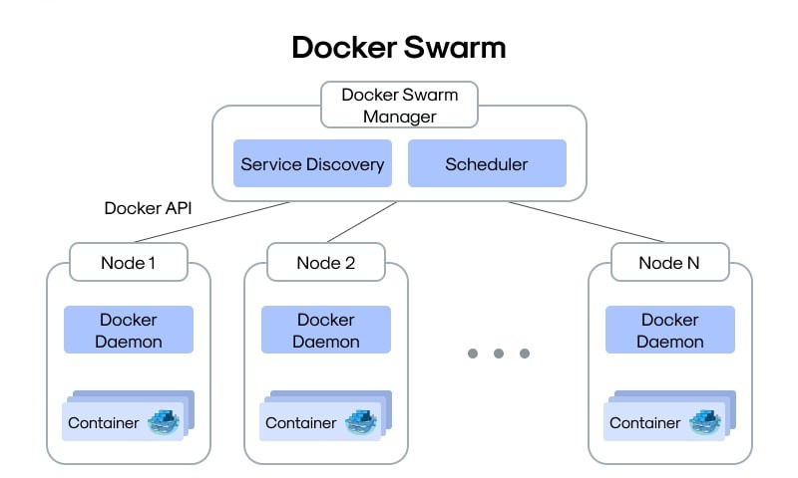

# 3. What is a Cronjob?

A cronjob is a time-based job scheduler in Unix-like operating systems. It allows users to run scripts or commands automatically at specified intervals. The cron daemon (`crond`) runs in the background and checks the `/etc/crontab` file and `/etc/cron.*` directories for scheduled jobs.

Use Cases:  
- Daily database backups  
- System cleanup tasks  
- Sending reports  
- Scheduled notifications

# 4. Creating a Basic Cronjob

Step 1: Open the crontab editor

***crontab -e***

Step 2: Add a cron entry

***\* * * * * echo 'Cron ran at $(date)' >> /home/ubuntu/cron.log***

Step 3: View running cron jobs

***crontab -l***

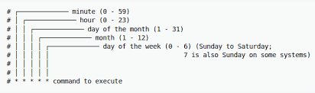

# 5. Key Tips for Cronjob Usage

- Use absolute paths in scripts.  
- Make sure scripts have execute permissions.  
- Redirect output to a log file to debug issues.  
- Use `crontab -l` to verify jobs and `systemctl status cron` to check the cron service status.

# 6. Conclusion

Docker Swarm is ideal for managing containerized applications at scale across multiple machines, while Linux cronjobs help automate time-based system tasks. Understanding and using both tools effectively—separately—helps maintain system health, automate workflows, and improve productivity.